601 W 26th Street,
Suite 325 - 237
New York, NY 10001
212.496.1429
suzanne@sunshineassoc.com

As of 12/31/2020
Since 2001, Suzanne Sunshine has closed hundreds of NYC real estate transactions on behalf of nonprofit, arts, and social impact organizations. In addition, she proactively contributes to the social impact of those organizations via philanthropy and art.

Over her 33-year career in real estate, Suzanne has been driven by a two-fold mission:
​
- Strengthen communities, create healthier work environments and jobs that provide dignity and purpose, reduce inequality and poverty, and support the arts.
- Optimize an organization’s critical real estate assets (leased or owned), thereby positively impacting their bottom-line as well as their stakeholders, employees, and communities.
​
Prior to founding S. Sunshine & Associates in 2009, Suzanne led the development of real estate advisory and brokerage services for nonprofit organizations at Cushman & Wakefield and CB Richard Ellis. She also served as a broker, focused on nonprofits, at Time Equities.
​
Earlier in her career, Suzanne created a new division of publications and media at the Dana Foundation, a nonprofit devoted to brain science. And at the Local Initiatives Support Corporation (LISC), a nonprofit social investment bank that partners with community development corporations, she helped raise $24 million for The Retail Initiative, a national equity fund, that brought supermarket-anchored retail into inner-city neighborhoods, including the Pathmark Center in Harlem.
​
Suzanne began her career with Equitable Real Estate, assisting in the marketing of funds from institutional investors, including providing long-term debt for affordable housing and economic development. She also acted as Assistant Art Curator, helping to develop the private and public spaces of Equitable’s new headquarters, the first Class A building on Seventh Avenue connected to Rockefeller Center.
​
Suzanne received her MBA in Real Estate from Columbia Business School in 1991. As an undergraduate at Brown University, where she received her B.A. in International Relations in 1985, she helped to curate an exhibition on the orgins of Abstract Expressionist Art in New York City during World War II.
​
Suzanne lives in NYC with her husband Bill. They have two children in college.

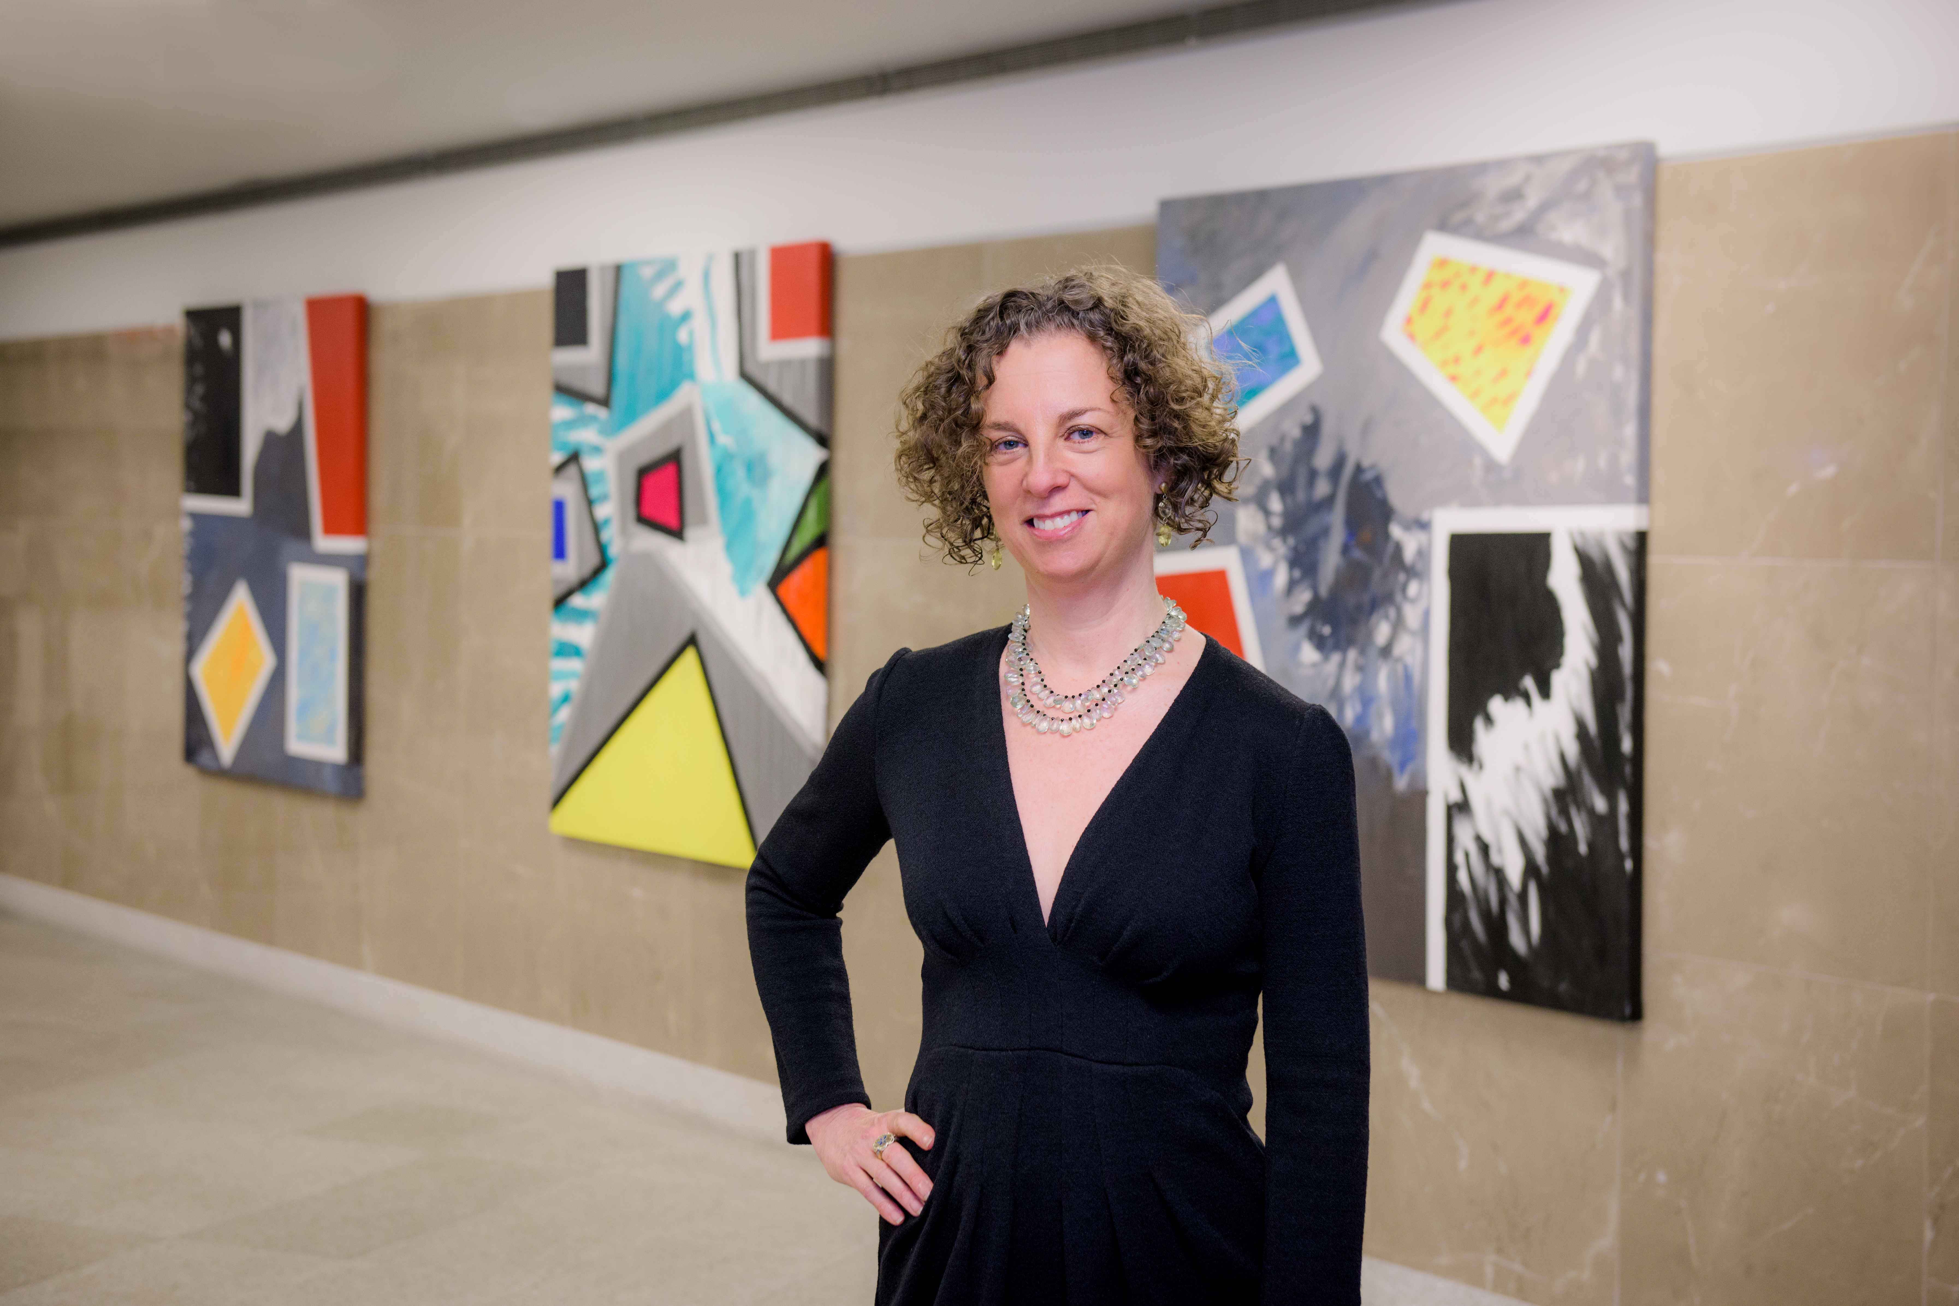
Suzanne Sunshine in front of three of her paintings installed in the lobby of The Actor’s Equity Fund building at 729 Seventh Avenue, NYC — photo Alison Sheehy

Licensed New York State Real Estate Broker
Certified B Corporation®

